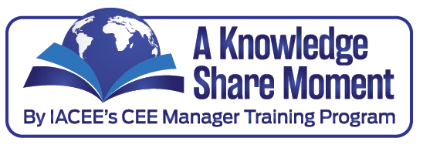

**TIPS** for Developing and Managing Massive Open Online Courses **(MOOC’s)**

Provided by: Nelson Baker, Ph.D., Dean, Georgia Tech Professional Education

Massive Open Online Courses (MOOC’s) have dominated recent higher education publications as well as the popular press and provide new opportunities to reach learners around the world in very dramatic fashion. Several of our IACEE members are involved with creating MOOC’s and have taken leadership roles in founding this new form of online education. Sites, such as Educause (<http://www.educause.edu/library/massive-open-online-course-mooc>) provide more background on what is a MOOC, and sites such as MOOC-List (<http://www.mooc-list.com/>) are providing mechanisms to showcase the growing number of courses. With total course enrollments approaching 10 million across the major MOOC platforms (e.g., Coursera, EdX, Udacity) how should a continuing education unit think about managing this new form of education delivery and student interaction? Below are some tips:

* Plan early and often. The development of these courses is more work than nearly everyone expects at the onset. The formal process of planning what is to be accomplished and how one will set out to reach these goals is crucial for a successful MOOC.
* Test your course within the platform prior to the start of the course. Understanding the platform and how it works is crucial for successful student learning within a MOOC. When you link to other resources, the platforms can be very brittle and the locations to where you are linking can be overwhelmed by the thousands of learners accessing the materials at one time. Testing should also include copyright searches to be sure the materials presented are lawfully appropriate for the course.
* Form teams. Teaching in this environment is analogous to the lead surgeon in an operating room. While the faculty member is critical, there are lead roles for others to support the instructor, from instructional designers for helping shape pedagogy to achieve learning objectives; to videographers and video-editors to best capture small portions of time with the instructor telling the story, demonstrating a technique etc.; to data analysts to collect and study the course learning data; to ITC consultants to help the faculty member make best use of the technology and understand the platform being utilized; to media specialists to help faculty work in a world of media and many questions; and, to teaching assistants who assist the instructor in managing the student questions and guiding discussion across the student forums.
* Embrace learning. Collect information and data about the learners in your MOOC class and learn what is important for them so as to improve all of your courses. By so doing, improvement in all forms of education interaction benefiting learners and instructors alike is possible.
* Managing MOOC development. Meet often with the faculty, offering the team-based resources helping to build trust with a team-based concept. Encourage faculty to reach out to their fellow faculty colleagues to review content and directions. Test all aspects of the course before launching and then stay with the faculty during the course offering with frequent contact to further support needs as they develop.
* Expect the unexpected. As with any new endeavor, we are learning about these new tools and how the tools and students utilize them. Share your lessons with others, learn from others and explore a new world for reaching global learners.

If you have not yet participated in a MOOC, I encourage you to do so. Learning about these new platforms will keep your programs the best they can be for the students.